*Start a new Python project folder … do not reuse the previous workspace … As with any keyboard-driven console-like environment, developing muscle -memory for the common commands is also part of the learning curve.*

**Importing and analyzing data from the “Internet of Things” (IoT)**

* Importing packages
* If you don’t have the package, it will throw an error
* 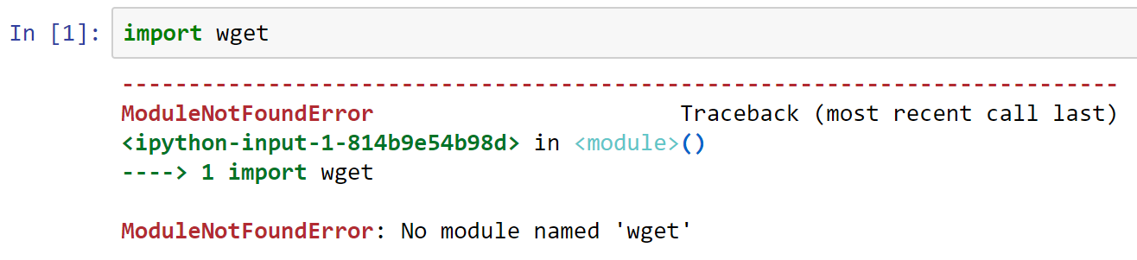
* If you are missing a package you can just get install it
* Running the code below will install the missing package
* 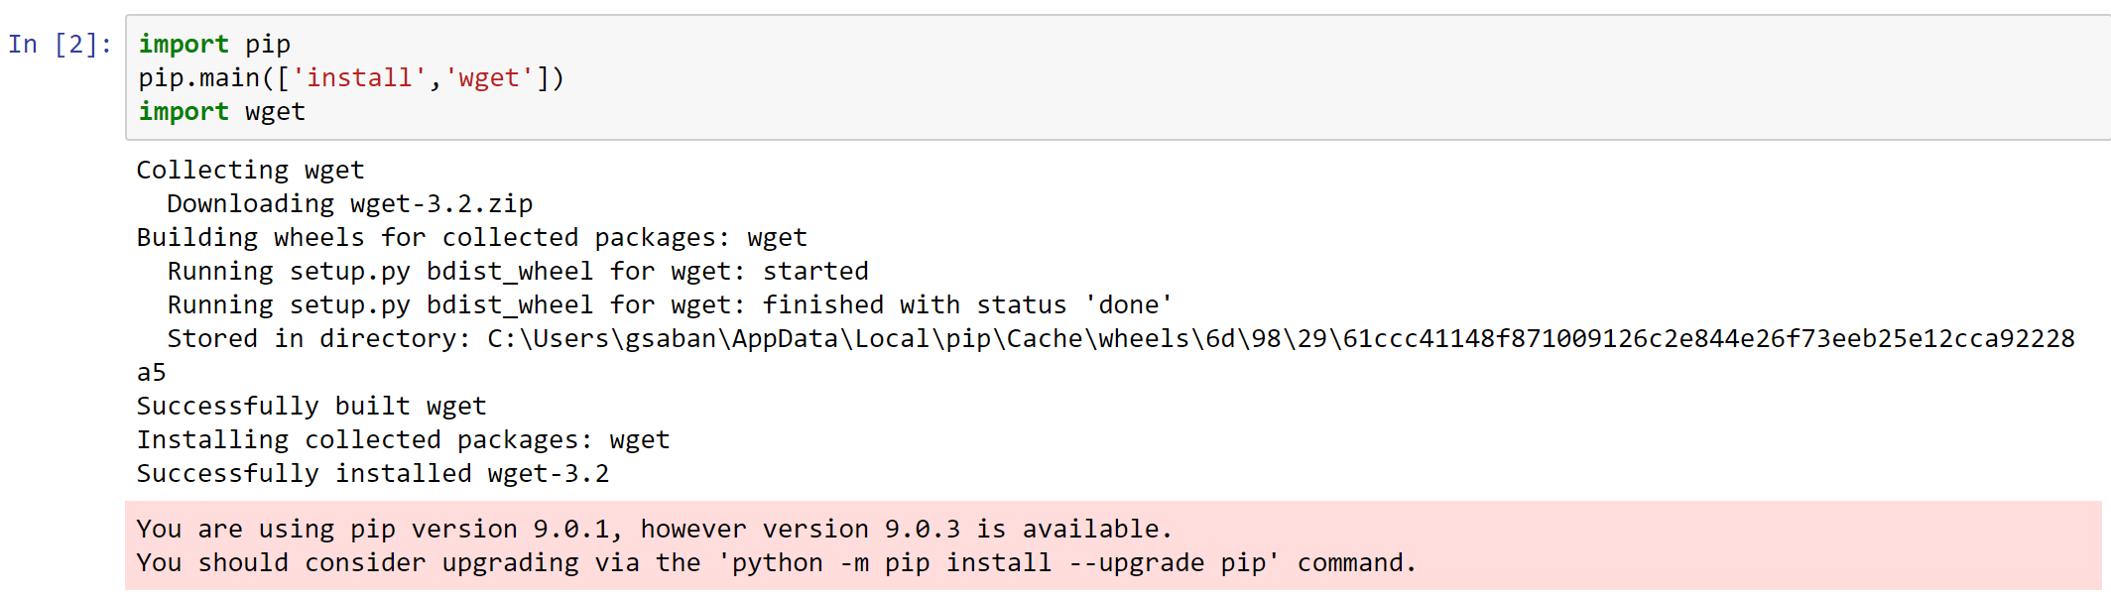
* If you have a package that maybe potentially missing, you can make your code robust so it will download it if it hasn’t been installed yet.
* 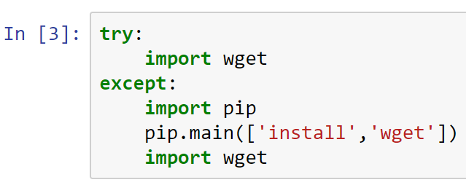
* Run the complete code above
* wget is a tool that allows you to get a file from the Internet
* Let’s get the stock data for ticker Tesla
* The try-except block above is a technique to install missing packages
* wget is deprecated so we will use pandas_datareader
* Making sure that it will be installed in your system
* 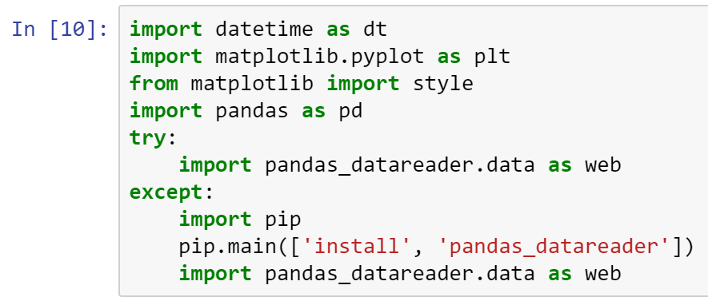
* Execute, and wait for Python to install pandas_datareader package
* You may see something like below
* 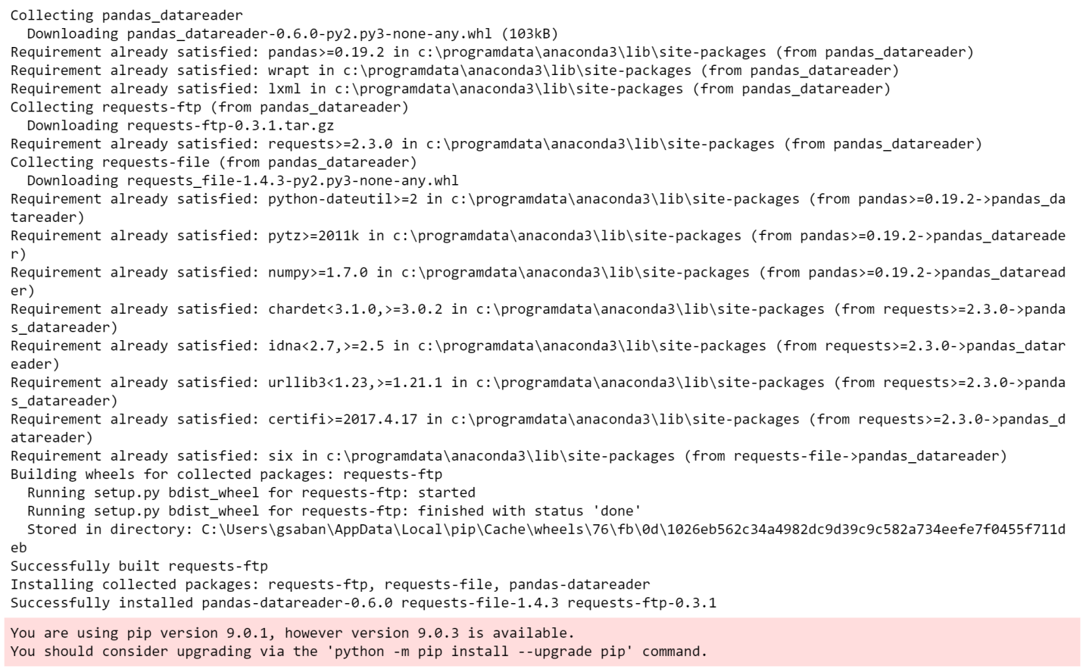
* Panda is a data analysis library
* Some excellent links:
* <https://pythonprogramming.net/data-analysis-tutorials/>
* <https://pandas.pydata.org/>
* Setting up the plot style
* 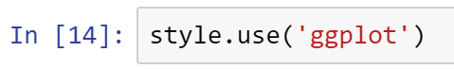
* Setting up data range
* 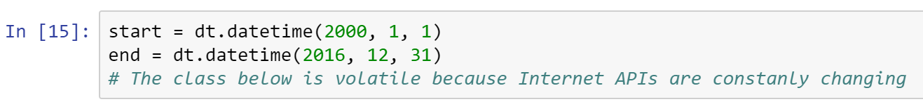
* The class below is a fix to the latest error in Panda’s datareader
* The text for the YahooDailyReader class is also found in Canvas (in case you don’t want to type the class’ code below)
* 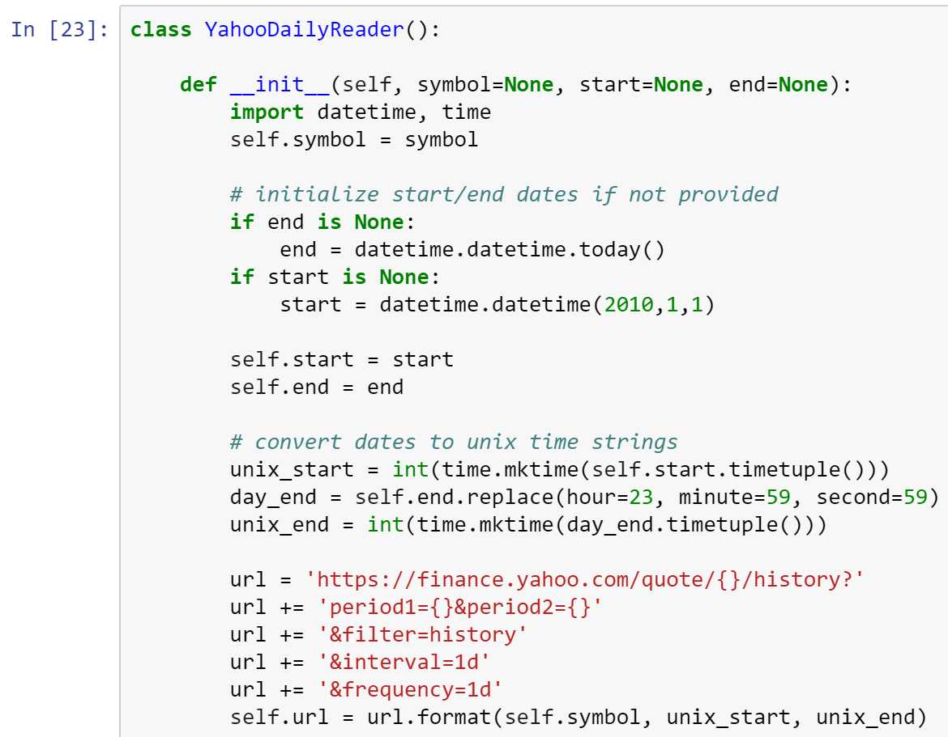
* 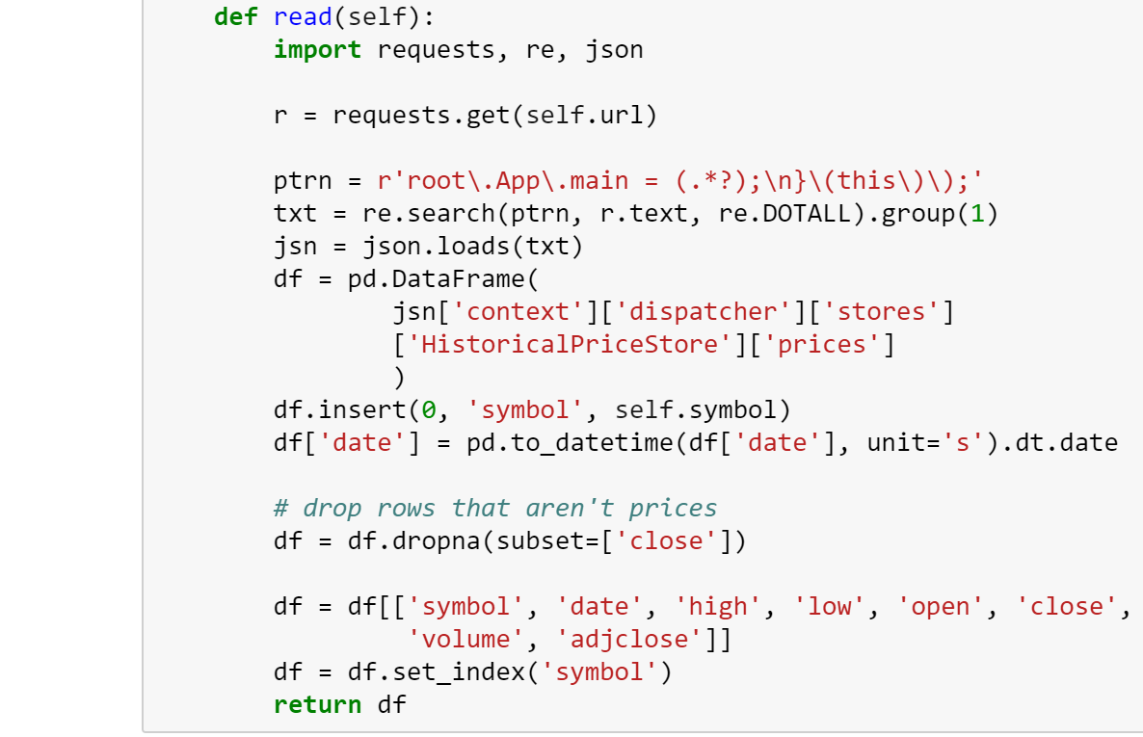
* Now, let’s read Tesla’s stock info from the Internet
* 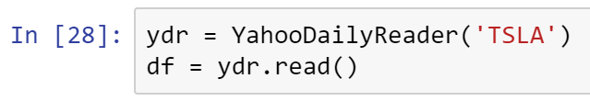
* Displaying the DataFrame’s (df) first 6 rows. Note how the data wraps around.
* 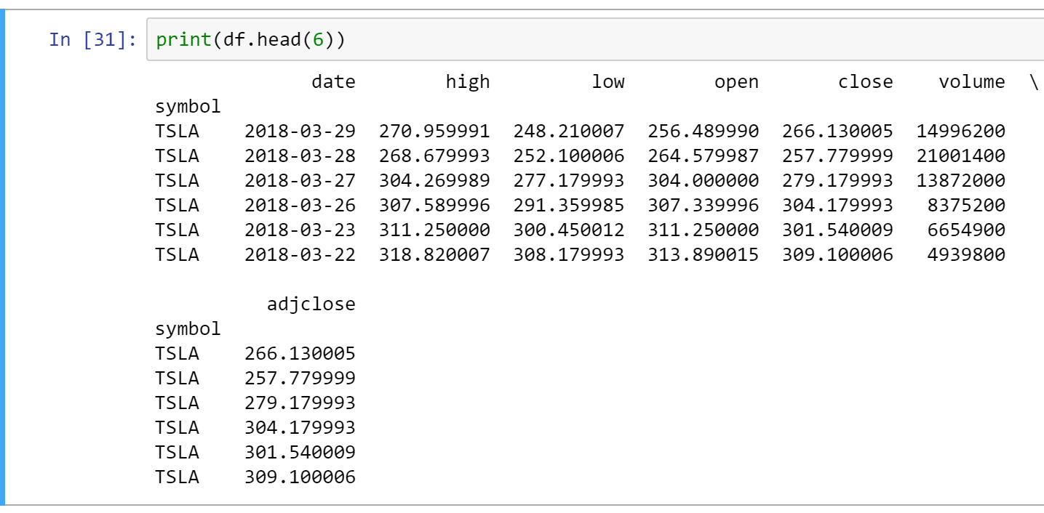
* You can print specific columns
* 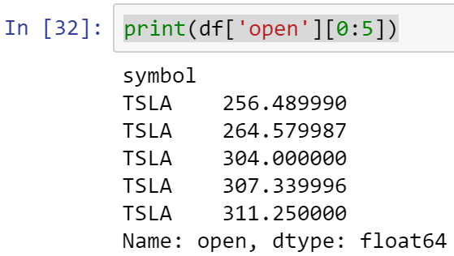
* Storing DataFrame as a csv file
* 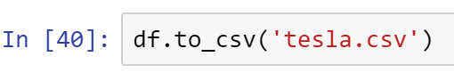
* 
* Reading the static file tesla.csv
* 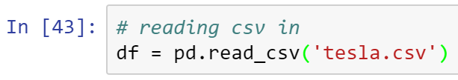
* Verify success by reading a few records
* 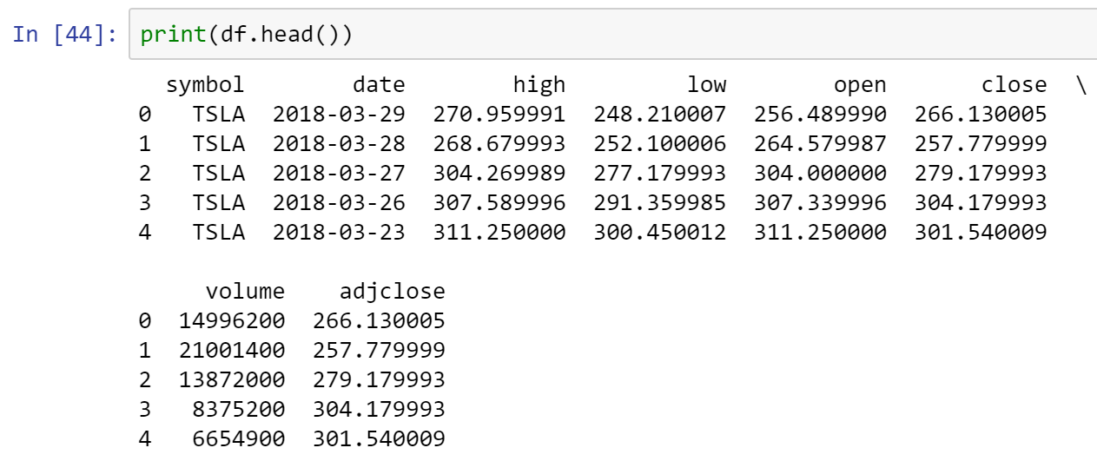
* Preparing the index for plotting
* 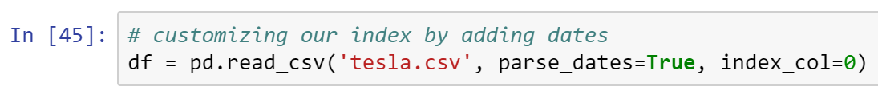
* If the date column was absent in your csv file, the code above will add it
* Now, plotting the data to gain some insight about Tesla’s stock
* 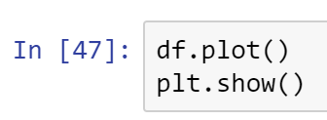
* 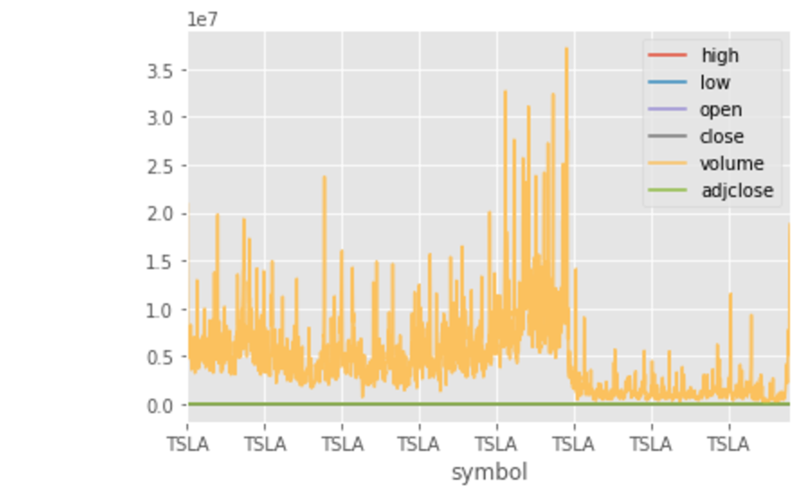
* If you want your x-axis to be the date, you can just remove from your csv file the symbol column
* Plotting specific column
* 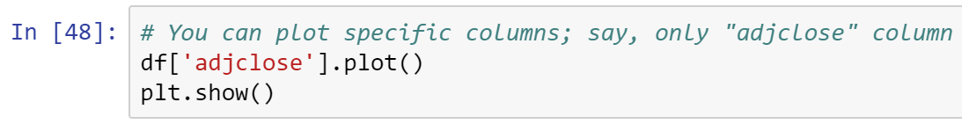
* 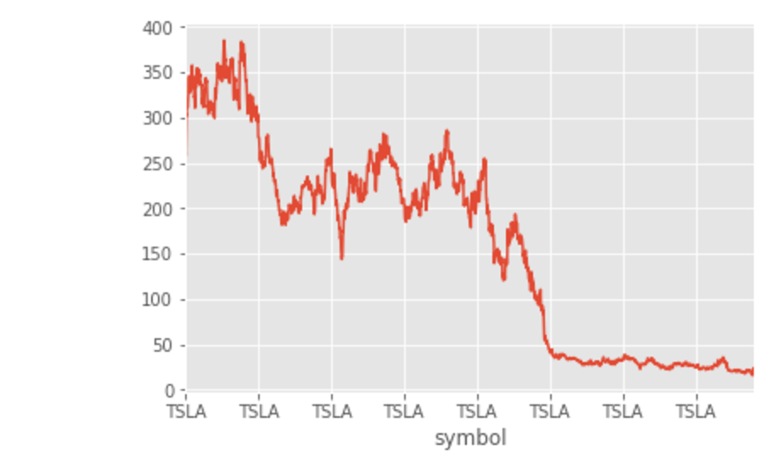
* 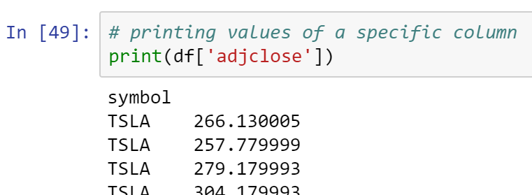
* 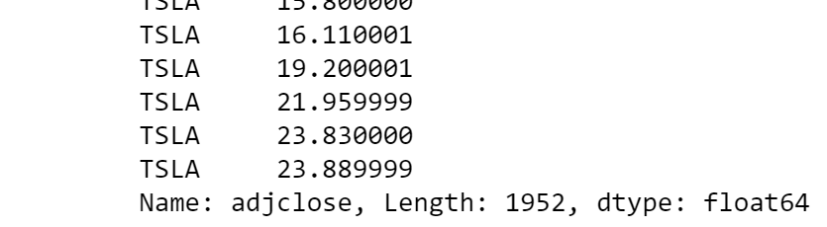
* 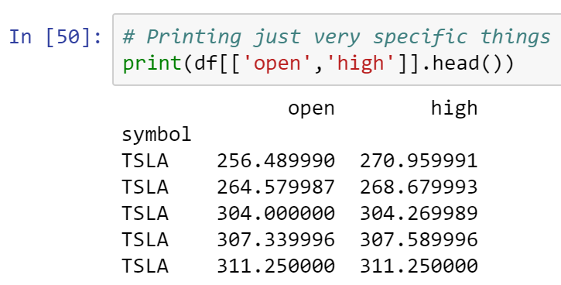
* What do you make of the graphs above? In other words, what do these graphs tell you about Tesla company?
* Answer:
* ___________________________________________________________________
* ___________________________________________________________________
* ___________________________________________________________________
* What ideas do you have on how to tweak this program in order to gain insight into the current market for personal and professional use?
* Answer:
* ___________________________________________________________________
* ___________________________________________________________________
* ___________________________________________________________________

____________________________________________________________________________

* All submissions should be separate from other exercises and quests. Please do not lump all your answers into one document and re-using that same workspace to gain multiple points. Thanks.
* Place your name at the bottom of your code, download your Python program in html format, and submit your work in Canvas.